**ASSIGNMENT-1**

**1.Write HTML code to develop a web page having the background in red and title “My First Page” in any other color.**

**Code:**

<html>

<head>

<title>

My First Page

</title>

<head>

<body style="background-color:red;">

</body>

</html>

**Output:**

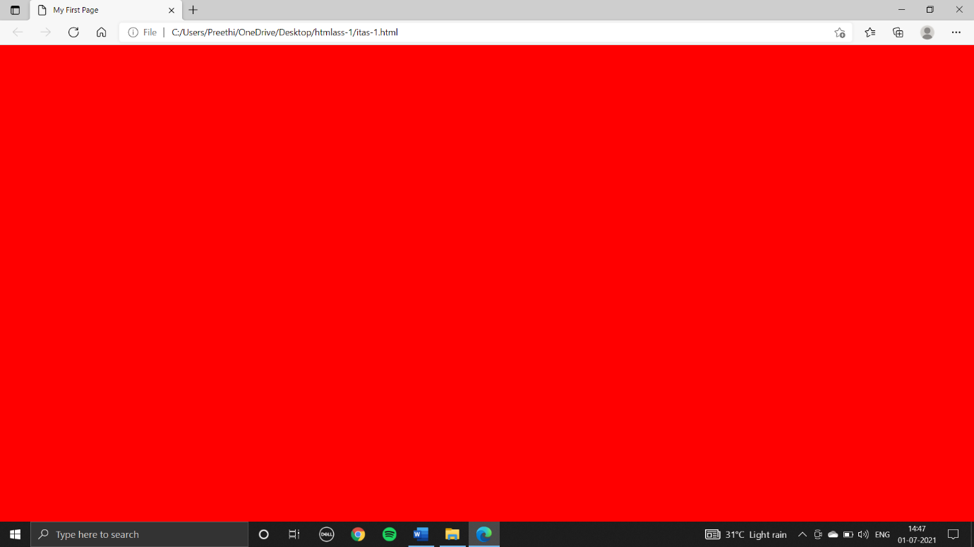

**2.Create an HTML document giving details of your name, age, telephone number, address, TLC code & enrolment number aligned in proper order.**

**Code:**

<html>

<head>

<title>

my details

</title>

</head>

<body>

<p><b>NAME:</b>Preethi</p>

<p><b>AGE:</b>18</p>

<p><b>TELEPHONE NUMBER:</b>12334567890</p>

<p><b>ADDRESS:</b>Telangana,Karimnagar,Manakondur H.NO:8-50/2</p>

<p><b>TLC CODE:</b>505469</p>

<p><b>ENROLMENT NUMBER:</b>18143</p>

</body>

</html>

**Output:**

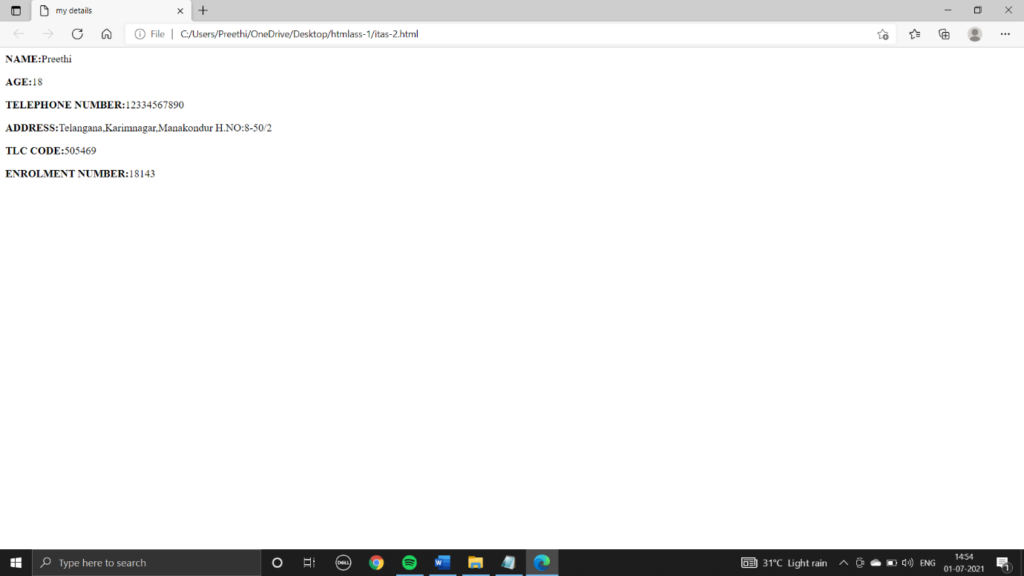

**3.Write an HTML code to design a page containing text, in form of paragraphs giving suitable heading style.**

**Code:**

<html>

<head>

<title>

paragraph

</title>

</head>

<body>

<h1>heading-1</h1>

<p>Laptops combine all the input/output components and capabilities of a desktop computer, including the display screen, small speakers, a keyboard, data storage device,<br> sometimes an optical disc drive, pointing devices (such as a touchpad or pointing stick), with an operating system, a processor and memory into a single unit.<br> Most modern laptops feature integrated webcams and built-in microphones, while many also have touchscreens. Laptops can be powered either from an internal battery or by an external power <br> supply from an AC adapter. Hardware specifications, such as the processor speed and memory capacity, significantly vary between different types, models and price points.

</p>

<h2>heading-2</h2>

<p>A laptop, laptop computer, or notebook computer is a small, portable personal computer (PC) with a screen and alphanumeric keyboard. These typically<br>have a "clamshell" form factor, typically having the screen mounted on the inside of the upper lid and the keyboard on the inside of the lower lid, although 2-in-1 PCs with a detachable keyboard are often marketed as laptops or as having a "laptop mode." Laptops are folded shut for transportation, and thus are suitable for mobile use.[1] Its name comes from lap, as it was deemed practical to be placed on a person's lap when being used.

</p>

<h3>heading-3</h3>

<p>Today, laptops are the used in a variety of settings, such as at work, in education, for playing games, web browsing, for personal multimedia, and general home computer use.<br>As of 2021, in American English, the terms laptop computer and notebook computer are used interchangeably;[2] in other dialects of English one or the other may be preferred.

</p>

<h4>heading-4</h4>

<p>HTML (HyperText Markup Language) is the most basic building block of the Web. It defines the meaning and structure of web content.<br> It defines the meaning and structure of web content. Other technologies besides HTML<br> are generally used to describe a web page's appearance/presentation ( CSS ) or functionality/behavior ( JavaScript ).</p>

<h5>heading-5</h5>

<p>Bring in your Money work by contributing from the solace of your home. 100% Data Accuracy.<br> If you don't want to waste your time in quarantine, invest now and generate extra income.

Email Alerts.Jobs Worldwide.</p>

<h6 style="font-size:30px">heading-6</h6>

<p>Online Application for Lateral Recruitment; Online Recruitment Application (ORA) Status of Recruitment Cases<br>(Advertisement-wise) Forms for Certificates; Recruitment Tests; Recruitment Requisition; Recruitment cases kept on hold on account of Pending Litigations;<br> Representation on Question Papers; Government Users . Central Government; Union

</p>

</body>

</html>

**Output:**

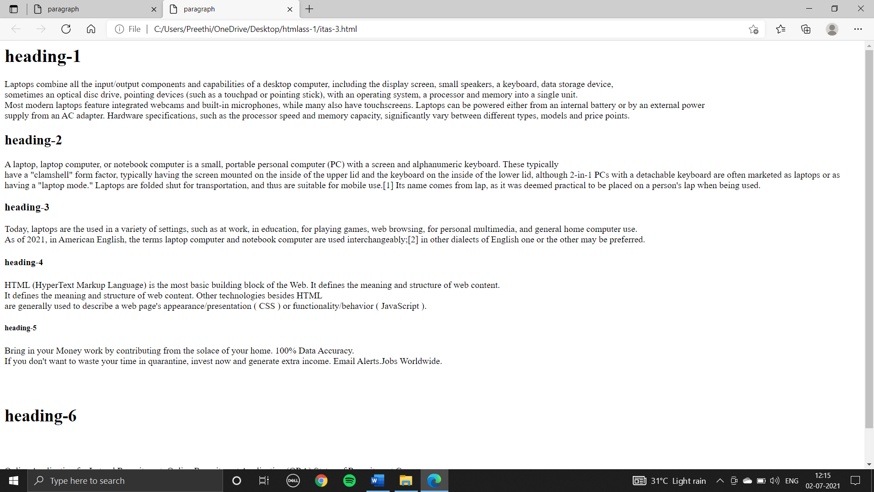

**4.Create a page to show different attributes of font tag. create a page to show different attributes: italics, bold, underline. Design a page having background color yellow, giving text color red and using all the attributes of font tab.**

**Code:**

<html>

<head>

<title>

font tab

</title>

</head>

<body style="background-color:yellow;color:red;font-size:50px;">

<p>

<i>italics</i><br>

<b style="font-size:100px">bold</b><br>

<u>underline</u><br>

<del>deleted text</del><br>

<ins>added content</ins><br>

H<sub>2</sub>O<br>

10<sup>2</sup><br>

<style="font-family:verdana;">verdana<br>

<em style="font_size:30px">emphasis</em><br>

<mark style="color:red;">hilighted text</mark><br>

<strong style="font_size:30px">important text</strong><br>

</p>

</body>

</html>

**Ouput:**

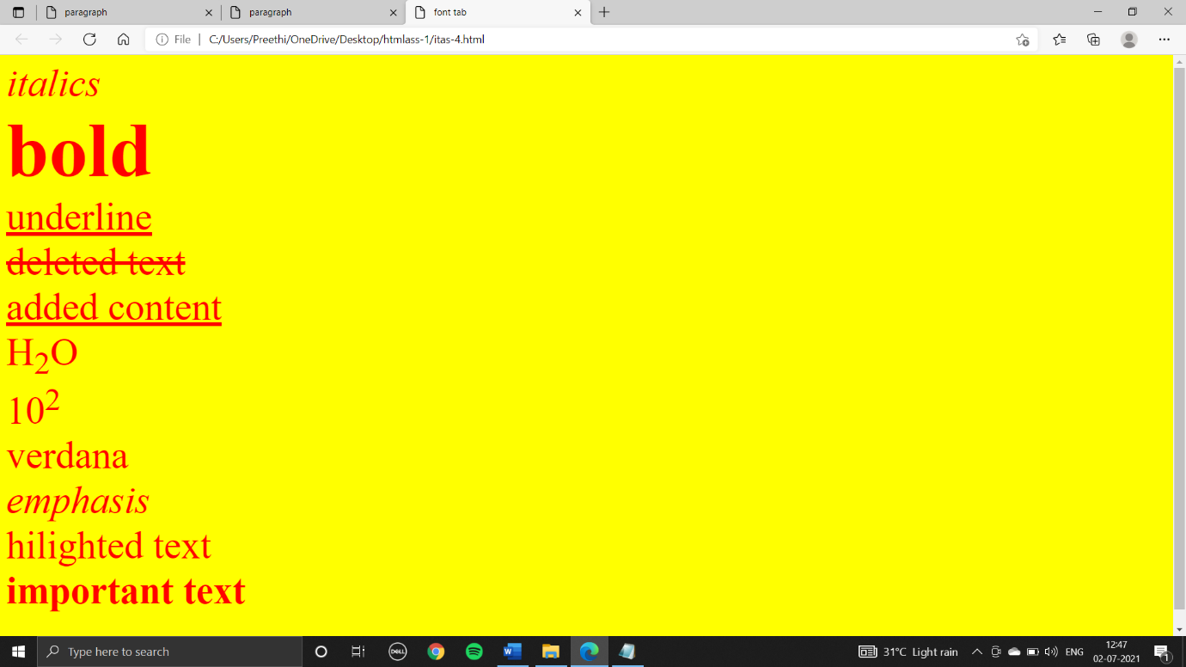

**Done by:**

B.preethi

ID:B181356

AB-2,305,CSE